Summer 1 Planning – Topic
- Cubs are 2-3 years old, red font is Cubs focused. Bears are 3-4 years old and are in their preschool year, blue font is Bears focussed. Black – shared resource differentiated orally &/or by expectation
- During circle times the children will be spilt into groups depending on age and ability.
- The weekly forest school sessions in the Primary School field are alternated half termly between bears & cubs.
- Individual planning for each child is completed by the key worker focusing on the child’s individual next steps and interests.
- Highlight code: red less than 50% achieved, yellow up to 75% achieved, green over 75% achieved
Term: Summer 1 2018 Theme: People who help us Role play area: Home / Police station

 | Prime areas |  |  | Specific areas
 | Personal, Social and Emotional Development | Communication and Language | Physical Development | Literacy | Maths | Understanding of the World | Expressive Arts and Design
Cubs (2-3years) | Self Confidence and Self Awareness  Separates from main carer with support and encouragement from a familiar adult.  Managing Feelings and Behaviour  Can express their own feelings such as sad, happy, cross, scared, worried.  Making Relationships  Seeks out others to share experiences. | Listening and Attention  Single channelled attention. Can shift to a different task if attention fully obtained – using child’s name helps focus.  Speaking  Uses simple sentences (e.g.’ Mummy gonna work.’)  Understanding  Understands ‘who’, ‘what’, ‘where’ in simple questions (e.g. Who’s that/can? What’s that? Where is.?). | Health and Self care  Drinks well without spilling.  Moving and Handling  Imitates drawing simple shapes such as circles and lines.  Links to EAD, Health eating and Mark making | Reading  Fills in the missing word or phrase in a known rhyme, story or game, e.g. ‘Humpty Dumpty sat on a ...’.  Writing  Distinguishes between the different marks they make. | Numbers  Uses some language of quantities, such as ‘more’ and ‘a lot’.  Shape, Space and Measure  Notices simple shapes and patterns in pictures. | People and Communities  Learns that they have similarities and differences that connect them to, and distinguish them from, others.  The World  Notices detailed features of objects in their environment.  Technology  Shows an interest in technological toys with knobs or pulleys, or real objects such as cameras or mobile phones. | Exploring and using Materials and Media  Shows an interest in the way musical instruments sound  Being Imaginative  Beginning to use representation to communicate eg drawing a line and saying ‘that’s me’.

Bears (3-4 years) | Self Confidence and Self Awareness  Is more outgoing towards unfamiliar people and more confident in new social situations.  Managing Feelings and Behaviour  Can usually tolerate delay when needs are not immediately met, and understands wishes may not always be met.  Making Relationships  Initiates play, offering cues to peers to join them. | Listening and Attention  Joins in with repeated refrains and anticipates key events and phrases in rhymes and stories.  Speaking  Questions why things happen and gives explanations. Asks e.g. who, what, when, how.  Understanding  Beginning to understand ‘what and ‘who’ and `when’ questions.  Links to Phonics | Health and Self care  Understands that equipment and tools have to be used safely.  Moving and Handling  Draws … circles using gross motor movements.  Links to EAD, Health eating and Mark making | Reading  Shows interest in print in the environment.  Writing  Ascribes meanings to marks that they see in different places. | Numbers  Knows that numbers identify how many objects are in a set.  Shape, Space and Measure  Beginning to talk about the shapes of everyday objects, e.g. ‘round’ and ‘tall’. | People and Communities  Knows some of the things that make them unique, and can talk about some of the similarities and differences in relation to friends or family.  The World  Talks about why things happen and how things work.  Technology  Shows an interest in technological toys with knobs or pulleys, or real objects such as cameras or mobile phones. | Exploring and using Materials & Media  Taps out simple repeated rhythms.  Being Imaginative  Makes up rhythms.

Summer term 2018
Please add your ideas for group activities or area ideas.

w/c | Special dates | Role play / theme | Ideas
Monday 16th April | St George’s day  Shakespeare’s birthday | Home  Police station area at table | Make flags for George’s day, make dragon, story, cbeebies  Shapes – flag , shape mat matching game (extend Fred)  MYO shield using white and name in middle of red cross  Finger gym 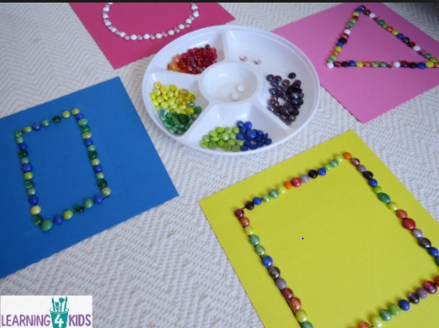  https://www.bbc.co.uk/cbeebies/watch/lets-celebrate-st-georges-day  ipad jigsaw - https://www.bbc.co.uk/cbeebies/puzzles/st-george-jigsaw
23rd April | Monday Police visit | Home  Police station area at table | Police visit  Police finger play & songs  Shapes – make police car 2d shapes & cut & stick shapes to make police car / station  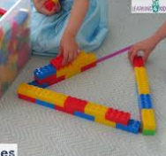  Shape hunt  finger gym  Outside – shapes in chalk for chn to hop, jump, stride etc to, &/or throw bean bags into  Wanted posters – chn draw & staff annotate
30th April |  | Inside: home  Outside willow hut: garden centre | Planting in garden troughs? - Plant quick blooming flowers & edible plants (toms, pots) = snack  Tidy garden with chn – add things to entice wildlife? Add wind chimes / sensory area (herbs, lavender, colours etc)? (ongoing)  Use gardening catalogues for cutting & sticking  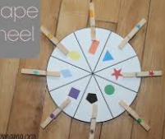  Make Soapy Slime: 1 cup of Soap Flakes, 3 cups warm water, food colouring, large mixing bowl, large container or tray and an electric beater. As you beat the water, food colouring and soap flakes the mixture multiples, so I placed the large bowl on top of our container to catch the over flow.
7th May | Bank holiday Monday  Dentist visit Wednesday 10am |  | Read Jack & the beanstalk, / Casper’s beanstalk  Intro & begin to use dotty name cards  Make a wormery  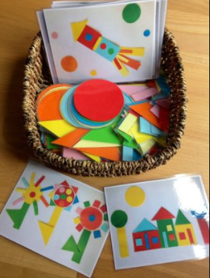
14th May | 19th Harry & Meghan wedding  15th Ramadhan begins | Add drapes, princess dresses – Kathryn to adapt | Friday – afternoon tea to celebrate? Chn make for snack, heart shape cutters, decorate biscuits, make crowns,  Collage & paint bunting & flags  Shape wedding dresses 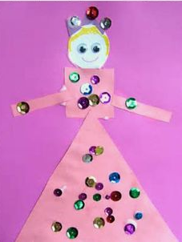  Small world & junk model castles
21st May | chicks |  | Hatch eggs –